SEDL 4673 – Open product with any quote if has no opening trade.

Current Behavior

This is current flow after Opening Parallel changes. When needsMMQuoteToOpen is set, Quotes within EPW can open if it has no opening trade and isTimeToOpen.
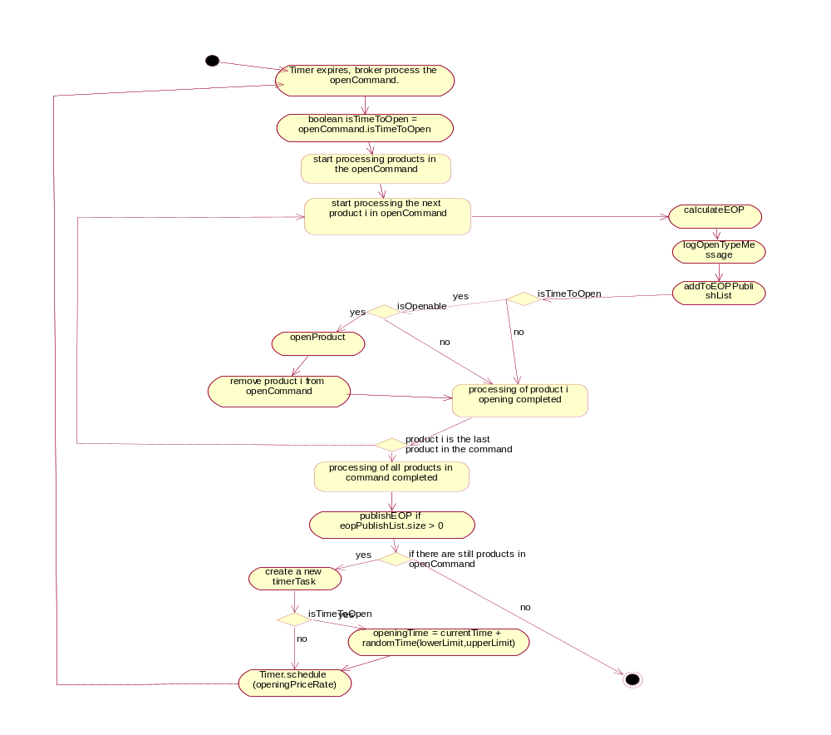

New Requirements

- If session is configured with needMMQuoteToOpen (ONE_MAIN and HTS), if there is no opening trade, any width quote will open the product immediately.
- If needsDPMQuoteToOpen, it will still need the standard quotes based on the Opening Strategy.
- Remove initial time delay for opening when state is changed from PreOpen to ROTATION. This will be done by changing trading property for inital time delay to be 0. This will be changed for ONE_MAIN and HTS only. Other sessions will not be affected.

Changes
- OpeningPriceIndicator and OpeningReporter will add new method openImmediate( ) – if needsMMQuoteToOpen and has no opening trade, return true, else false.
- OpeningReporter.canOpen will change to getAllQuotes in stead of standard quotes when checking quotes for needsMMQuotesToOpen.
- BrokerImpl – if openImmediate, no need to wait for timeToOpen as illustrated above anymore, open product.
- OrderBookImpl – add method to getAllQuotes.
- SetTradingProperties – change to set OpeningPriceDelay for ONE_MAIN and W_MAIN to be 0.

Files Changed:
/vobs/dte/domain/Java/interfaces/com/cboe/interfaces/domain/Quote.java
/vobs/dte/domain/Java/interfaces/com/cboe/interfaces/domain/OpeningPriceIndication.java
/vobs/dte/server/Java/impls/com/cboe/businessServices/orderHandlingService/OrderImpl.java
/vobs/dte/server/Java/impls/com/cboe/businessServices/orderBookService/OrderBookImpl.java
/vobs/dte/server/Java/impls/com/cboe/businessServices/brokerService/BrokerImpl.java
/vobs/dte/server/Java/impls/com/cboe/businessServices/marketMakerQuoteService/QuoteImpl.java
/vobs/dte/server/Java/impls/com/cboe/businessServices/marketMakerQuoteService/QuoteNullImpl.java
/vobs/dte/server/Java/impls/com/cboe/businessServices/orderBookService/OpeningReporter.java
/vobs/dte/server/Java/impls/com/cboe/internalBusinessServices/productStateService/QuoteDerivedImpl.java
/vobs/dte/simulator/Java/impls/com/cboe/emulation/marketMakerQuoteService/QuoteEmuImpl.java
/vobs/dte/server/scripts/bin/ SetTradingProperties

Performance Concerns
As we removed the opening initial delay, the opening is going to be in a shorter period of time, we will have to see how it does in perf environment.

The perf plans for Opening Block Processing Performance Test Plan should be good to use.

Rollout Concerns
As the OpeningPriceDelay trading property is global, we can install the code first and after all BC rollout is completed, we can change it to be 0.

Alternatively, the value can be changed prior to the rollout if management approves.

